**Project Proposal: Retail Store Sales Forecasting**

**1. Project Overview:**  
This project aims to develop a sales forecasting model for a retail store using historical sales data. By leveraging data analytics and machine learning techniques, we aim to provide accurate sales predictions that can help optimize inventory management, marketing strategies, and overall business operations.

**2. Objectives:**

* Collect and preprocess historical sales data for analysis.
* Perform exploratory data analysis (EDA) to uncover trends and seasonal patterns.
* Develop and evaluate different forecasting models to predict future sales.
* Deploy a predictive model that provides real-time or batch sales forecasts.
* Implement monitoring and reporting mechanisms to track model performance.

**3. Scope of Work:**  
**Milestone 1: Data Collection & Preprocessing (2 Weeks)**

* Gather historical sales data, including features like date, promotions, holidays, and weather.
* Clean the dataset by handling missing values, removing duplicates, and normalizing data.
* Conduct EDA to identify trends, outliers, and seasonality.

**Milestone 2: Data Analysis & Visualization ( 1 Week)**

* Perform statistical analysis to understand the relationship between sales and external factors.
* Develop visualizations (line charts, bar graphs, heatmaps) to explore trends and correlations.
* Create interactive dashboards for data exploration.

**Milestone 3: Model Development & Optimization( 2 Weeks)**

* Optimize model hyperparameters to enhance accuracy.

**Milestone 4: Deployment & Monitoring( 2 Weeks)**

* Enable real-time and batch predictions for business use.
* Implement MLOps practices for model tracking, version control, and monitoring.

**Milestone 5: Documentation & Presentation ( 1 Week)**

* Compile findings and methodologies into a final report.
* Present the results, demonstrating how the forecasting model improves sales planning and decision-making.

**4. Expected Deliverables:**

* Cleaned and processed dataset.
* Exploratory Data Analysis (EDA) report.
* Forecasting model with performance evaluation.
* Deployed application for sales forecasting.
* Final project report and stakeholder presentation.
* GANTT Chart

**5. Task Assignment & Roles**

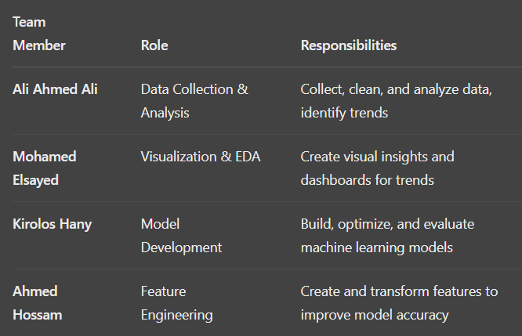

**6. Risk Assessment & Mitigation Plan**

|  |  |  |
| --- | --- | --- |
| Risk | Impact | Mitigation Strategy |
| Poor Data Quality | High | Perform thorough data cleaning and preprocessing |
| Model Overfitting | Medium | Use cross-validation and regularization techniques |
| Deployment Challenges | High | Ensure cloud scalability and monitor model drift |
| Lack of Stakeholder Adoption | Medium | Provide clear documentation and training |

**7. Key Performance Indicators (KPIs)**

|  |  |
| --- | --- |
| KPI | Description |
| Forecast Accuracy | Measure how closely predictions match actual sales |
| System Uptime | Ensure model availability for real-time predictions |
| Inventory Turnover Rate | Evaluate stock movement efficiency |
| Cost Savings | Reduction in stock wastage and storage costs |
| User Adoption Rate | Track engagement and utilization of forecasting insights |

**8. Conclusion**

This project, using a robust dataset and a well-divided team structure, aims to create a forecasting system that empowers the retail store with proactive planning. By identifying seasonal trends, optimizing stock, and delivering accurate predictions, the solution will minimize losses and improve customer satisfaction through better product availability.